Advertisement Production for Television
By Michael Gomersall

Structures and techniques of television advertisements
Television advertisements are used by companies to sell their products. It is not an easy task as there are so many products out there competing for the consumers’ attention. So advertisers want consumers to have a bond with their products, to be excited by them and to have product loyalty.
There are a variety of narrative structures that advertisers use in adverts. A narrative simply means the way a story is told and here are some examples of different narrative structures.
There are linear or sequential narrative structures. This structure tells us a story in time with a beginning, middle and an end.
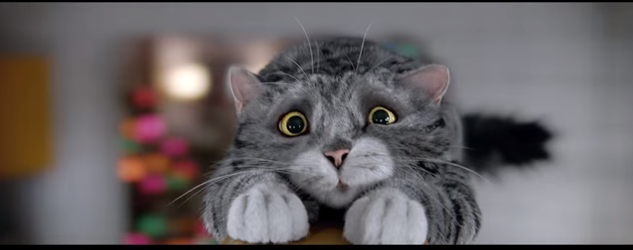https://www.youtube.com/watch?v=kuRn2S7iPNU
In this Sainsbury’s Christmas ad there is a linear structure but there are also realist and anti-realist narratives as well. The realist narrative is a disaster happening at Christmas and people coming to help and make Christmas good again. The anti-realist elements are all the events of the disaster with a CGI cat at the heart of it. This ad has animation in it which can add humour,
Another example of a realist ad is St John’s Ambulance -Save the Boy. It is realist because the situation could definitely happen and it is showing the importance of knowing first aid.
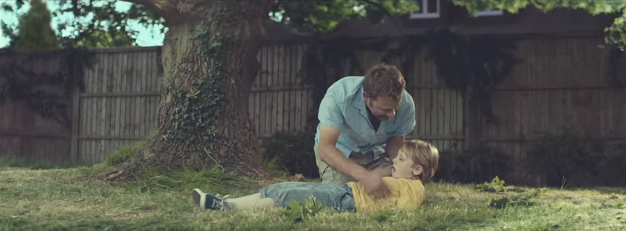
https://www.youtube.com/watch?v=YQNXJpuLKwU
Here is an example of an anti-realist ad advertising blue smarties coming back and that smarties don’t have unnatural colourings in them. In the ad the smarties are represented as people in coloured suits who live in a big smarties tube,
https://www.youtube.com/watch?v=rZoeY9WczgQ
An example of a non-sequential ad would be the driving safely ad ‘Always wear a seat belt.’ The ad starts at the end and goes backwards and then forwards again showing the difference when you wear a seatbelt
https://www.youtube.com/watch?v=WWN6kchSI2E
Some ads are animated or use animation in them. Here is an example of an animated ad for Kit Kat which suggests that taking a break is like continuing a quest which taps into people’s enjoyment of quests in games. Advertisers can tap into anti-realist narrative structures and consumers’ imagination and needs.
https://www.youtube.com/watch?v=_yBmCNGFrkA

Other types of narrative structures include talking heads and documentaries. These are often used together and use experts or people affected by the issue that the product is hoping to solve.
In this example there is a talking head of a woman who is doing an experiment to see how her teeth feel after a night’s sleep. There is also a voiceover showing some of the research proving that the product is good.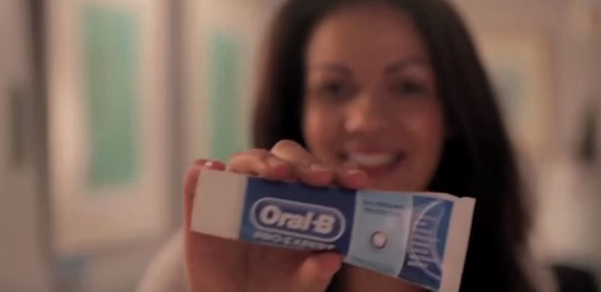
https://www.youtube.com/watch?v=O2F5Z2b1ZZE
Another example of a talking heads video is for Capital Radio which shows musicians, djs and artists promoting the radio station. It is cool, well-paced, fashionable and bright, reflecting Capital Radio’s image.
https://www.youtube.com/watch?v=jaWqrcn7CXU
This advert uses great sequencing with the camera panning between the people, a white background and good music.
Ads can also be stand alone or in a series. Some ads have a theme and have a series of ads on that theme for example Barrys Tea bags on every day having its golden moments. These ads don’t use the same characters or follow a story though so they would be seen as stand-alone. Ads in a series use the same characters. An example of this would be Go Compare with the guy singing. These ads can be seen as humorous and as they evolved and the advertisers realised the consumers found the main character irritating they created parodies, for example him getting hit by a football kicked by football manager and player Stuart Pearce or him singing operatically in a huge theatre to adoring fans.
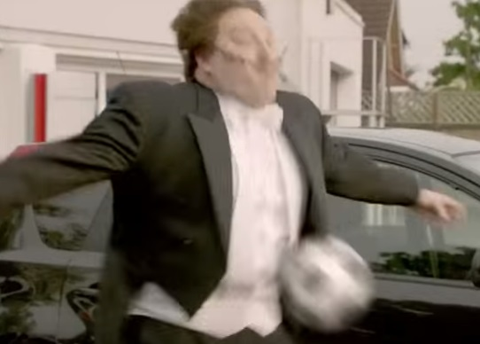
http://www.gocompare.com/tv-advert/ https://www.youtube.com/watch?v=caOAk-V6P94

Styles
Apart from the different narrative structures advertisements can use different styles. Here are some examples of styles
Humorous
There are lots of examples of humorous ad. Consumers like a laugh and they might associate a product with feeling good. They can be silly, far-fetched, cute, tongue in cheek and harmless. The Sainsbury’s Mog at Christmas and Go compare ads mentioned above are examples of humorous styles. Also the go Compare ads are humorous.

Surreal
Surreal ads aren’t always obvious what the product is. They are often off the wall. In this example a belly is chasing a runner singing ‘belly’s going to get you.’

https://www.youtube.com/watch?v=wHlvKQwZFSI

Dramatic
Ads can use dramatic style to capture the consumer’s attention and to create emotions. There are lots of different types of dramatic ads. For example a lot of safety ads like wearing a seat belt and checking your fire alarm have a sense of drama. In this one below, the child asks the parents to make a promise to check their fire alarms. At the end it is revealed the child is a ghost who died in the fire.

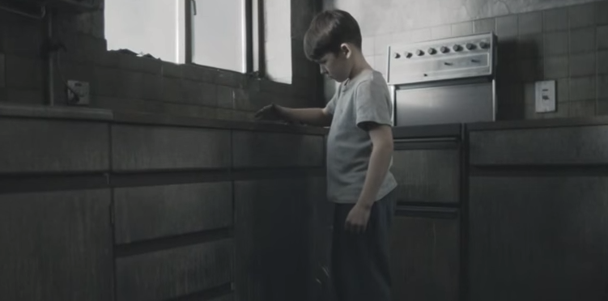

https://www.youtube.com/watch?v=Ir2bekewg-8

The Guinness, white horses ad has a different sense of drama showing waiting, anticipation and thrill.
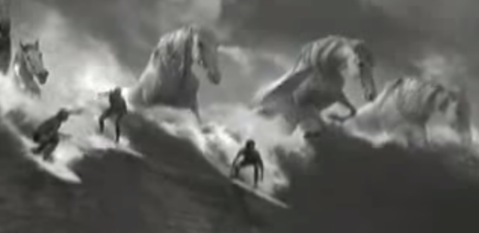

https://www.youtube.com/watch?v=Y9znA_dwjHw

Codes and Conventions in Advertising
Codes and conventions can be used in advertising but it is still worth creating a fresh ad to fit in with the message the advert is trying to make to the consumers that the advertisers are aiming at. There are some really obvious codes like people having fun out drinking, a shocking scene in road safety, woman washing their hair for shampoo ads and images of the product throughout the ad particularly at the end. Ads can use ideas like, ‘so bad, it’s good.’
I shall look at some of the codes and conventions in some of the adverts mentioned above.
The Sainsbury’s ad is less of a TV ad and more something they would hope would go viral on the internet. For a start the internet loves cats. It’s so long they can make into a series showing different bits each time. It doesn’t show the shop or any blatant Sainsbury’s imagery. It does show subtle Sainsbury’s images including a close-up shot of the oranges which is part of Sainsbury’s iconography. It is shot like a film and a book (the night before Christmas) with the usual Christmas messages (family, sharing, community, saving Christmas) and iconography (tree, lights, turkey etc.). The ad uses standard cinematography, close-ups, tracking shots, dark lighting for when everything is sad, bright lighting when everything is happy. They also use a narrator (like a book), music and sounds to help create the effects.
In the toothpaste ad it is shot like a video log giving it an amateurish feel. Its feels personal as you are in a pretty girl’s bedroom and she is talking to you. They use a slow zooming close-up on the product, a chart with a comparison with a male voiceover,r which gives it a scientific feel and a tag line ‘brushing is believing’.
In the Capital radio ad they are using fast panning, quick cuts and the white background hides edits so some CG would have been used. They use the logo at the beginning and the end as well as using celebrities. Using celebrities, building up sentences is an example of iconography as consumers can readily identify them.
The Reebok ad is shot like a chase scene from an action movie with fast editing and using a hand held camera. There are special affects like the belly driving a motorbike off a bridge (this is also the iconography of an action movie.) There is also that technique of a moment of calm which is a staple of comedic action movies. The music is -thrash metal and the lyrics are like a playground taunt and funny. There are also sounds of the motorbike. In the moment of calm-there is elevator music.

Techniques
Advertisers need to have a well thought out strategy understanding who the consumer is, what their needs are, what their attitudes are and their habits when it comes to using the products. This information has to be relevant.
An ad can contain hidden and overt messages. An overt message is the obvious, open message the ad is trying to put across. Examples of overt messages from the above ads might be ‘check your smoke alarm or this toothpaste keeps you teeth clean and fresh all through the night. Overt messages are what the advertiser wants the consumer to know about their product. Hidden messages may be to do with lifestyle. For example the Capital Radio’s advert’s overt message would be to listen to Capital Radio but the hidden message is that if you want to be cool, fashionable, in the know, connecting in with celebrities then listen to Capital Radio.
These messages also have emotional responses or association. For example the Reebok ‘bellies going to get you’ ad shows a fit guy being chased by a belly. He is strong and fit and some-one men could identify with and the emotional response would be fear of having a belly and needing to keep fit and the thrill and drama of the chase associating it with the adrenalin you get from exercising (implying you need to buy the reebok products) of the chase.
In the test your smoke alarm the child is looking directly at the camera and talking directly to the viewer asking them to swear on their child’s life that they will test their alarm. This invokes an emotional response of how they would feel if they didn’t do it. Parents want to keep their children safe from outside harm and do not want to be responsible for putting their child in danger.
The Reebok gives a solution to a problem e.g. the bellies going to get you unless you buy our shoes and keep fit. It also has a life-style appeal about keeping fit and has a self-perception of being a hero in an action movie when you are out running.
The St John’s Ambulance offers the benefits of knowing first aid, as well as working on an emotional response (fears and worries) (like in the test your smoke alarm ad) of keeping your children safe.
The Smarties ad appeals to mothers who don’t want to give their kids chemicals as well as to children as it is colourful and fun.
The toothpaste ad is offering a USP of still having clean teeth after sleeping all night. It also shows the advantages over other products.
Capital Radio uses celebrity endorsement and people might have a positive self-perception from seeing the ad and identifying with listening to the station.
The Sainsbury’s ad shows a lifestyle appeal of community and sharing and fun and overcoming adversity together. It also uses its brand identity with its logo and the shot of the oranges.
The Kit-Kat ad evokes the lifestyle of escaping the hum drum, claustrophobic world of the office
Advertisers are looking at the assumptions, hopes, dreams, expectations, worries and fears of consumers. They give the consumer reasons to believe that their product will deliver the promised benefits and gives proof to persuade the consumer that their product will meet their needs.
Regulation
Advertising is regulated by the Advertising Standards Authority (ASA) and by Ofcom.
The Advertising Standards Authority makes sure that ads across most mediums in the UK (such as TV, cinema radio, print, internet, posters etc) are responsible, honest and inoffensive. They are the industries regulatory body and do not have legal powers but they can pass on cases to Ofcom which does have legal powers.

Examples of decisions made by ASA is that OREAL made exaggerated claims about a mascara and that The Sofa King could not use its tag line Sofa King low as there was a pun using a bad word in the tag line.

Ofcom (Off ice for Communication) is an independent government approved regulatory body that works with TV advertising (amongst other things) making sure that adverts are held to certain standards. This includes areas such as;

- Protecting under 18’s
- Protecting the public from harm and offence
- Making sure that there is no incitement to crime
- Respect of religions
- Due impartiality
- Due accuracy

Audience Information
Advertisers use a range of ways of getting information about their audiences.
Audience Measurement Panels measure who is watching certain programmes. BARB (the Broadcasters’ Audience Research Board) gathers this information and advertisers can use this information to target their ads.
Ratings are how who is watching is measure. Programme makers and advertisers want the ratings to be good so that more people can see their product. Ratings are assessed daily by BARB and they can help advertisers target their advert slots. Ratings are quantitative research (numbers)
Face to Face Interviews and Focus Groups give more qualitative information to advertisers. These show how the audience related to their ad. Experienced interviewers will ask the individuals and groups questions to find out their reactions. Examples of information they might be trying to get from the individuals or groups may be; did they get what the product does, did they relate to the characters, how did they feel when they watched an ad, what message did they pick up.
Multiple opinions can be expressed in the focus groups (as opposed to the interviews).
Questionnaires can also check out audiences responses. They can get more information from questionnaires but it is not as in depth as with face to face. There is less effort in getting information but the audience needs to be well targeted so that it is they represent the group they are trying to reach
Programme profiles
Broadcasters’ Audience Research Board (BARB) creates programme profiles through the information they gather so they know who is watching what programme.

Television Research Agencies
RSMB is a television research agency that works with BARB to develop products and services so that they can analyse the information that BARB collects. They design, monitor and analyse systems to effectively measure audiences.

Sources of Information
Rates Cards
Advertisers look at rates cards so that they know what it is going to cost to run an advert at a particular time slot or for a particular programme. The advertiser will pay a different amount for more popular shows, Christmas times, time of the day, region and who the target audience is. Advertisers can also pay for a stand-alone ad or run a campaign (like Christmas ads). The length of the ad is also a factor.
Advertisers’ Information Packs
These packs are created by the provider to give advertisers the information they need to make informed decisions about where and when they should place their adverts. They might include information like events, products, audiences and statistics.
Research Agency Websites
Research agencies gather information for an advertiser when they are launching a new campaign. This could include budgeting, target audiences, potential slots as well as other data that has been gathered from questionnaires or focus groups. They do the work for the advertisers.

Audience Classification
Advertisers classify their audiences in different ways in order to target their ads effectively. There are some basic ways such as by gender and by age. Here are some other more in depth ways that audiences are classified.
Standard Occupational Classification
Below is a table showing how consumers are classified by their occupation with examples of their media consumption
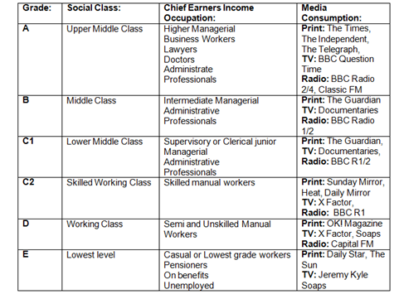
http://hannahsvideo.blogspot.co.uk/2013/04/standard-occupational-classification.html

Psychographics
Another way that advertisers classify audiences is through psychographics. They break the audience into different types so they can design their adverts to target these groups. Here is a table showing some psychographic information
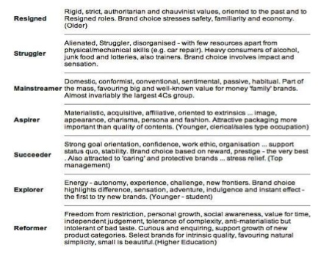
http://www.slideshare.net/Lucasjwarren/audience-information-26730685

Geodemographics
Demographics classify the audience based on age and gender and geo-demographics is a way of breaking the audience by geographical area. The idea is that people from the same geographical region might share certain traits in common. Advertisers can see if a campaign is more successful in one area than another. They might also use a narrator with a regional accent.

References

The Structure and Techniques of TV Advertising (from Moodle)
The Structures and Techniques of TV Advertising (Powerpoint) from Moodle
Persuasion – Advertising Educational Foundation (from Moodle)
https://prezi.com/6hlhbny1l-jd/genre-and-narrative-styles-of-tv-adverts/
http://advertisingtechniques321.blogspot.co.uk/search/label/Advertising%20Techniques%201
http://www.slideshare.net/seanofford/tv-ads-form-and-style
http://aaronunit30.blogspot.co.uk/2013/03/codes-and-conventions-of-tv-advertising.html
http://cmpkerriroberts.weebly.com/uploads/3/8/9/8/38982807/codes_and_conventions_of_tv_adverts.pdf
http://tvadvertdavidallan.blogspot.co.uk/2015/01/iconography-explained.html
http://rachelcemlyn-jones2.blogspot.co.uk/2013/07/codes-and-conventions-of-tv.html
https://en.wikipedia.org/wiki/Advertising_Standards_Authority_(United_Kingdom)#Broadcast_media
https://www.asa.org.uk/
http://stakeholders.ofcom.org.uk/broadcasting/broadcast-codes/broadcast-code/
http://www.slideshare.net/Lucasjwarren/audience-information-26730685
http://beccabootyunit30.blogspot.co.uk/p/audience-information.html
http://advertisingproductionbyryanhardy.blogspot.co.uk/p/sources-of-information.html
http://advertisingproductionbyryanhardy.blogspot.co.uk/p/audience-classification.html

