Multi-Camera Production Roles
By Michael Gomersall
Here are some of the roles of production staff needed for multi-camera productions.

Camera Operator
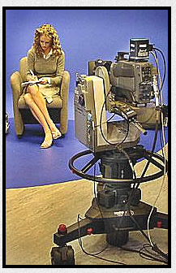
In a multi-camera production there is more than one camera being used. There may be a camera operator for each camera and the director would give instructions to a specific camera for what was needed. Examples may be ‘dolly in (for a close up) or dolly out (for a wide shot) or truck left or right (to move the camera to the either side). A camera operator would need the technical skills to know how to use the camera for the desired effect and also to understand the technical jargon of what the director is asking for. Cameras can be locked so they are steady or pan and tilted (sweeping horizontally and vertically). Cameras can be on dollys so they can be wheeled about or film movement smoothly.
Robotic camera mounts (see pic) can be used for predictable programming such as studio news or interviewers and the cameras can be adjusted remotely. For more unpredictable or fast moving shows camera operators are useful. Camera operators can also be responsible for making sure the composition and angle of a shot is the same throughout. They need to be alert and respond as the director requests.
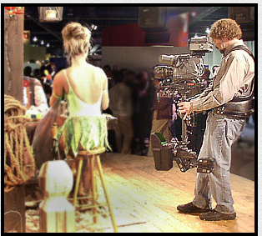
There are different types of equipment that camera operators would need to be familiar with. For example; a jib allows sweeping movements from the ground up to nine feet, a steadicam is like a hand held camera where the operator can run about but the camera is held fairly steady (see pic). Camera tracks and copters can also be used. Tracks are for more elaborate productions and allow the camera to follow the action smoothly outside by running along tracks and the copters are cameras which are in drones which can take aerial shots and be operated remotely.
In multi-cam productions the placement of the cameras is very important and there may be fixed shots (such as close-ups on each actor and a wide) or some fixed and a roaming. It is important not to double up on coverage.

Sound Mixing
In a multi camera production a sound mixer or engineer is responsible for the sound recording and mixing of the sound in a production. There are different roles connected to sound mixing. The sound supervisor would work closely with the director identifying specific crew and equipment needed. Crew that might be needed are gram operators (who play in, on cue, any pre-recorded music and/or effects), sound technicians (who place personal microphones on presenters to get the best sound capture) and boom operators (who work with booms or fish poles to record sound).
During live programmes a sound mixer or engineer is responsible for mixing sound sources for immediate transmission. They would have to monitor outputs, adjust levels and quality and cue music and effects.
In multi-camera productions as well as mixing sound sources, sound engineers would need to make sure that public address systems are next to camera monitors so that studio audiences can hear the programme too.

Switcher - vision mixing
A vision mixer can edit programmes live as they are being recorded. They need to have an overview and be familiar with how the programme will look as they mix different visuals from sources such as cameras, video, graphic generators and digital video effects. They use different transition methods such as cuts, mixes, wipes and frame manipulation Vision mixers work live or with multi-cam. Often there is a running order, particularly in game shows. This is usually decided by the producer. The vision mixer works closely alongside the director. A vision mixer would need to be very alert as the demands, particularly on live TV can change quickly and the vision mixer would need to be able to keep on top of this. For example in a news programme, the running order may change rapidly and the vision mixer may need to work from more than one visual source, for example adding graphics with name, location and date to relevant shots.

Director
Directors are responsible for the overall look and sound of a production. They need to work closely with producers and writers to realise ideas into finished programmes. They have to bring together various threads such as a clear vision, what materials are needed, managing and getting the best out of the team, working within a budget and to deadlines. Scripts have to be carefully prepared with the director, producers, script writers and editors ensuring that any technical, logistical or creative problems are ironed out. The final scripts are what the director and crew work from. Directors will liaise and work with actors, presenters and crew to make sure every-one knows what is expected. . During studio recordings or live transmissions the director will work closely with the vision mixer as well as communicating via talkback equipment to technical personnel such as camera operators, sound supervisors and floor managers to cue all movements. Directors need to be able to make decisions on the spot, taking feedback from crew, producers and what is happening.

Producer
A producer oversees a creative project from beginning to the end. They need to raise funding, research and assess ideas, control budget and pull together creative and practical talent. A producer deals with all aspects of keeping the project running smoothly so that the rest of the team can concentrate on their jobs.

Lighting
There are various roles in lighting in multi-cam productions including lighting director, console operators and electricians. The lighting director needs to work with the production team to design the specific look required for each shot. Lighting plans include the positioning of lights, the type and colour of lights that need to be used. In multi-cam productions lighting needs to be consistent so may be set up like lighting a stage play. An example would be to light from above (using rigged lights to the ceiling or grid). This may take more time to set up but will balance out as you will save time when shooting.

Floor Management
The floor manager liaises between the production team and the crew. They ensure that the crew knows what the director expects and can give directions to cast, crew and guests to keep the production on schedule. They would also check that the floor is clear, the scenery is in place and lights are on or off as needed. The floor manager would also maintain quietness when needed, call cues and make prompts as needed. Floor managers need to have great communication skills to convey information as needed from rehearsals to the wrap,

Graphics Generator
Graphics can be used in multi-cam productions and can be as simple as creating a back drop with a photo or as sophisticated as creating a visual backdrop. Most graphics used these days are computer generated. There are various software based systems which can use a computer as well as dedicated equipment used only for creating television graphics. The vision mixer can use these images and cut them in as needed. Graphics are used a lot, for example in weather forecasting. Other examples of simple graphics could be a banner scrolling across the page with information on it, logos or animation. These may be generated there and then in programmes like the news or may have been pre-created and maybe used every week like the logo in X Factor.

Autocue operator.
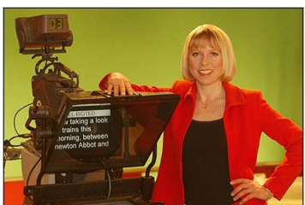
The Autocue is an important aspect of live TV as a presenter can see text while staring into the camera as they deliver their lines. An angled one way mirror reflects a mirrored version of the text (see pic). This gives presenters an air of professionalism and confidence in what they are saying. Having a good Autocue operator can get the best out of the presenter. The text has to be the right size, too small and they are straining to read, too big and the words can jump out at the presenter. Practising with a crew member can help regulate flow, pace and speed before time conscious presenters or guests come in. The autocue operator works with the director and onscreen talent to get the best out of the presenter. They will be attuned to repetitions and mistakes. The autocue operator can also add directions if needed perhaps in a different colour or format. The autocue rig needs to fit in with specific cameras and will need a little time to set up so that there is enough space, height and can be used with the cameras movements.

References
http://www.cybercollege.com/tvp017-2.htm
http://serife-multicamera.blogspot.co.uk/2013/05/job-roles-of-multi-camera-production.html
http://nishasreedharanmulticamera.blogspot.co.uk/2013/05/job-roles-of-multi-camera-production.html
http://creativeskillset.org/job_roles/313_sound_supervisor_tv
http://creativeskillset.org/job_roles/318_vision_mixer
http://creativeskillset.org/job_roles/294_director_tv
https://www.prospects.ac.uk/job-profiles/television-film-video-producer
http://creativeskillset.org/job_roles/298_lighting_director
http://www.premiumbeat.com/blog/3-tips-you-must-know-before-shooting-a-multicam-production/
https://en.wikipedia.org/wiki/Television_crew#Floor_manager
http://www.cybercollege.com/tvp026.htm
http://www.camberwellstudios.co.uk/film-production-guides/production-crew/68-the-importance-of-an-autocue-and-operator-.html

