Portfolio of Evidence to be presented by each student for:
Unit 16: Film and Video Editing Techniques
SOCIAL ACTION & THE COMMUNITY FILM ASSIGNMENT

Name: Michael Gomersall

Please provide a written comment that deals with all the italicized tasks below. You don’t need to write about all of listed content but it essential that you write about a minimum of two of the sub headings for the learning outcomes.
Unit content

LO1. UNDERSTAND THE DEVELOPMENT AND PRINCIPLES OF EDITING

LO1.1 Development: in-camera editing; following the action; multiple points of view; shot variation; manipulation of diegetic time and space; film, video; analogue; digital.

Task 1. Provide a written report to explain your understanding of the above media terms, also provide written details about camera and audio equipment you use to record production work. P1 M1 D1

In Camera Editing; In camera editing is when the sequence is shot in order. The editing process does not need to happen afterwards as the editing happens in real time. This can save time as you have the complete film as soon as the filming is over. You can plan out your shots in sequence and rehearse them. It might be useful for a wedding or a sports match. We didn’t use this in our social action project as it wouldn’t have added to what we were doing. If there was a specific event like following a fun run we might have used this by planning carefully – I think you would need experience to do this well.

Following The Action; This is where the camera follows an event in a movement or action scene. The camera doesn’t stay fixed but moves to capture the action. Sometimes more than one camera is used which means that different angles are seen as the subject moves and cameras are switched. This can give the subject depth and add excitement to an action sequence for the audience.

Multiple Points of View; Adding multiple points of view makes the film more enjoyable to watch. Multiple points of view is where the camera is looking at a object, but at different angles and different types of shots. We added in as many different shots, shot angles and different shots looking at the same thing to increase shot variety. These included point of view and over the shoulder. We tried to make as many shots as we could.

Shot Variation; Shot variation is the technique used in filming to create a sequence of images using movement. When we went to the Foyle hospice, we tried to do as many things as we could. We shot the landscape, the bedrooms, the day care centres, the nurses talking and much more, so we always had something to cut to whenever someone was talking.

Manipulation of Diegetic Time and Space; This is where, in a film, the editor changes the speed of which the film goes to show the audience a long period of time into a relatively short time. We used this in the film to show the inside of the hospice. I think it was a good technique as we were aiming at a young audience.

Film, Film used to be a thin piece of material, usually plastic that would be put into a camera to produce film or photography. Now most film is digital and filmed on a camera and saved on a memory card.

Video; A video is the recording, reproducing or broadcasting of moving visual images.

Analogue; The ‘old’ way of editing, that has been replaced by digital editing, it was used before digital cameras, whenever people used ‘film’ where they cut the film and put it together.
Digital; Digital is now the most popular type of editing. It is the easiest and works the best with modern cameras and it is easy to transfer on SD cards and Hard drives. It is easy to upload the footage on and edit it.

LO1.2
Purposes: storytelling, eg engaging the viewer, development of drama, relationship to genre, creating motivation; combining shots into sequences; creating pace.

Task 2. Describe how the above media terms are important to moving image productions. Give an account of you are intending to employ editing techniques and processes to tell your story? P1 M1 D1

Engaging The Viewer; Engaging the viewer is keeping the audience interested and making them want to watch. The purpose of media is to entertain, educate or inform your audience so all media needs to keep the audience in mind. I wanted my audience to understand a little bit about the work of the hospice as most people in the community have heard of it but not every-one would know what exactly it does. I wanted to show the audience about its work and how they could get involved through images and words. I particularly wanted to let younger people who might have lost a parent or relation to know about the healing hearts service. When we were researching I found the interviews quite long and the information wasn’t that entertaining so I used voiceovers with images to introduce topics and cut down the interviews so people would stay interested. The video of the hospice needed sensitive handling but I also wanted to make it accessible to younger people. I like having the young boy telling his story.

Development of Drama & Relationship to Genre; My social action was a documentary on the Foyle Hospice, so it wasn’t a drama as such. I still did try and tell a story introducing the hospice and then different aspects of the work through the interviews and cutaways, finishing with the lighting lives event to show what the hospice does. The documentary stayed on topic the whole time and I used music to add a little atmosphere.

Creating Motivation; Creating motivation is that the audience understands what you are doing as a film maker and coming along on that journey with you. I was trying to inform the audience of the services the hospice provides, the importance of the volunteers and the importance of the fundraising that is done by the local community.

Combining Shots Into Sequences; I used this technique a lot in the social action project. This is the process of putting the shots together in a sequence so it flows smoothly and looks good. The editing needs to be invisible so that the audience just sees one sequence.

Creating Pace; Creating pace in video can be used to speed up the film in say an action movie or slow it down in say a love story. This was a documentary and we wanted it to be sensitive yet appeal to a younger audience so we wanted a fairly smooth and even pace which would keep interest up but also have space for reflection. I think the music helps adds to the pace keeping the sensitivity and the space and I put shots over other shots to increase interest and make it nicer to watch.

LO1.3 Conventions and techniques: seamless; continuity; motivated; montage; jump-cutting; parallel editing; 180o rule; splicing; transitions, eg cut, dissolve, fade, wipe; cutaways; point of view shot; shot-reverse-shot; providing and withholding information; editing rhythm; crosscutting; cutting to soundtrack.

Task 3. Provide a written report to explain what the above editing conventions and techniques mean and give an account of the editing techniques you plan to use in your production. P1 M1 D1

Seamless; Seamless editing is where you put two different pieces of film together, and they still run smoothly into each other without any obvious difference. Most of my footage was cutaways to what the interviewee was talking about, I think in my documentary the part where we’re talking about the day hospice and the shots run seamlessly.

Continuity; Continuous editing is similar to seamless editing, it is when two pieces of film are running without any visible editing. Continuous editing is where you maintain a certain pace and keep the story on track, and keep it making sense,

Motivated; Motivated editing is basically having a reason behind every single edit that you do, although it really depends on the story, characters, theme and the pace of the documentary.

Montage; A montage is just a series of different clips of footage that are edited into a sequence that runs smoothly with continuity. I made a montage of the day hospice whenever we were talking about it.

Jump-Cutting; A jump cut is an editing technique when sequential shots of the same subject are taken with different camera angles. It can be used to add pace or create action. It gives the effect of jumping forward in time. I used a jump cut when Donall was talking but I put a cutaway over it so people wouldn’t notice.

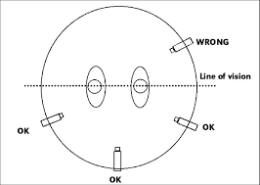
Parallel Editing; this shows two (or more) different things happening at the same time at different places and the camera jumps from one shot to another. Sometimes it may end with people meeting up. I didn’t need to use this technique on my video.

180º Rule; This picture describes the 180º rule, where the director will not go over a line of vision. The 180º rule makes sure that characters stay where they are supposed to. For example if in my interviews with Donall, if Ryan had crossed the line it would have looked as if we had swapped places. This technique can be used to show characters in relationship with each other or showing moving in a direction like 2 characters running toward each other. If the director crossed the line it might look like both characters are going in the same direction.

Splicing; Splicing is the old form of editing, used with film. It is a linear form of editing with a strip of film cut by a razor blade then stuck to other strips of film to put them together.

Transitions;

Cut; this is simply taking a bit of footage that you want and placing it into your timeline.
Dissolve; this is one shot, fading out into another shot, to make it more smooth.
Fade; This can be fading in from the beginning, or fading out at the ending, and it is baisically just the screen being black then fading to the shot, or the shot playing and then fading to black.
Wipe; When you place this transition into between two shots, the follow up shot will replace the former shot by coming in from one side of the frame until it finally is taking up the whole frame.

I used transitions for the credits. I used a transition to fade into Michelle as I had to cut off a bit of the voiceover and I wanted it to run more smoothly than cut it off straight away.

Cutaways; Cutaways are used to keep the audience interested, I used a lot of cutaways in my social action movie to keep the audience interested, because a moving shot of someone doing something related to what the interviewee is talking about, is more interesting than a still shot of the person talking.

Point of View Shot; Also known as POV, It is a very simple camera angle that makes it look like the camera is someone’s point of view, and we are seeing out of the characters eyes. It makes the movie feel more life like to the audience. I used point of view shots the video, for example, when I walked down the corridor in the hospice.

Shot-Reverse-Shot; Shot-reverse shot is where the camera shows one character looking at another character, and then it shows the other character looking back at the first character. It is important to keep the eyeline at the same level. I didn’t use this technique as it was interviews as opposed to a dialogue.

Providing and withholding information; This is where the audience knows information, that the characters in the movie don’t know. This is used more in drama to build tension.

Editing Rhythm; This is using transitions to edit the rhythm, you can make the rhythm faster or slower making the transitions slow or fast.

Crosscutting; This is a technique to show two different places, to show 2 things that are happening at the same time. The editor will show one shot of the action at one location, then switch to the action at the other location, and then back to the first location and so on.

Cutting to soundtrack. This is when the pace of the cuts is guided by the rhythm of the music. I used music between the mother and son talking to add a moment of reflection. I also did this at the end of the video so that the credits were paced to the rhythm of the music.

LO2. BE ABLE TO PREPARE MOVING IMAGE MATERIAL FOR EDITING

LO2.1 Preparation techniques: checking material for faults; marking up a script; labelling tapes; storing tapes or film; producing an edit decision list; creating bins; clarifying the purpose of the work with a client

Task 4. Write about and describe the editing terms and processes mentioned above

Checking Material for Faults; When I was working on the editing I had to always make sure that I was checking the materials for faults. This included checking that all the sound is level, and all the clips come in at the time that you want them to. There were faults with lighting which I removed by increasing the brightness. There were spelling errors which needed to be changed. I had to look over my editing several times after I was done to level the audio, and fix the time some clips come in and add text to make it look better.

Marking up a script; For our social action I had to make a script of some voice overs that we would do. I created these from the interview materials. I had to write up the interviews to get the information so that I could have the material at hand to create the script. Then whenever we made the film we had to change some of them, add in some, or take some out because our crew thought that they would work better.

Labelling tapes; Jamie Keys, the crew member in charge of equipment labelled and organised the tapes so we always knew where we were and where everything was.

Storing tapes or film; You need to store all your film, and keep backups of it, in case it corrupts or you lose it, you wouldn’t want to have to do a whole days filming again. We kept the material on the hard drive and in files on two different computers.
Producing an edit decision list; Our team sat down and discussed what we wanted in our film and we took down all the ideas that we had. I also kept in touch with Donall, the CEO and he gave feedback. He wants to change the music which I will do but I don’t have time before the project is due inanted. As the editor I had to take all these ideas into consideration and make the best I could out of them.

Creating bins; a ‘bin’ is now called a library and this is where you put your footage and sound to edit in your timeline. I used the library in Final Cut Pro.

Clarifying the purpose of the work with a client; I consulted with Donall (the CEO) by phone, by email and in person throughout the whole process of making our social action project. He had a lot of ideas that he wanted us to include and he guided us, not only on what to include but on certain sensitivities. He helped us make our ideas more clear and the final piece has been guided by his vision as well as our own. As well as guiding the process, Donall got back to me with a few changes that I needed to make on the final piece, he said I needed to change the music, and get some of the titles right (as I had them in wrong).

LO2.2 Preparing to edit: importing clips; bins; timelines; storage and folder management; online and offline editing; formats; resolution

Task 5. Provide screen shots of the editing techniques used. Command – Shift – 4 and select the relevant material on screen.
Screen shots of clips, bins, timeline, etc.(

Preparing to edit:
Importing clips; Importing files is very easy on the editing software that I was using (final cut pro) you just click File – Import, then choose the footage that you want imported.
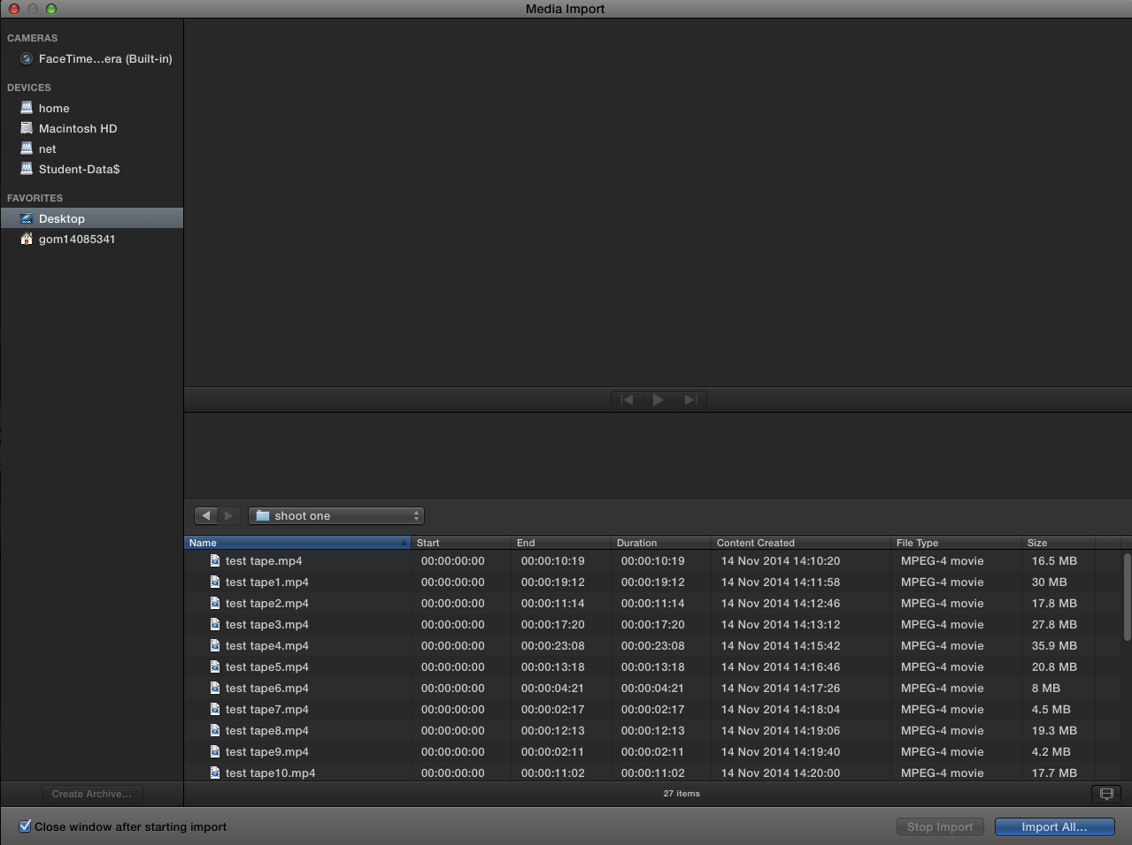

Bins; a ‘bin’ is now called a library and this is where you put your footage and sound to edit in your timeline.

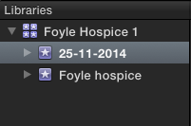

Timelines; Your timeline is the place where all of the clips go once you edit them, or you can actually edit them in your timeline. This is the digital version of the film strip, and once you finish your project and export it, whatever is on your timeline will be in the final film.
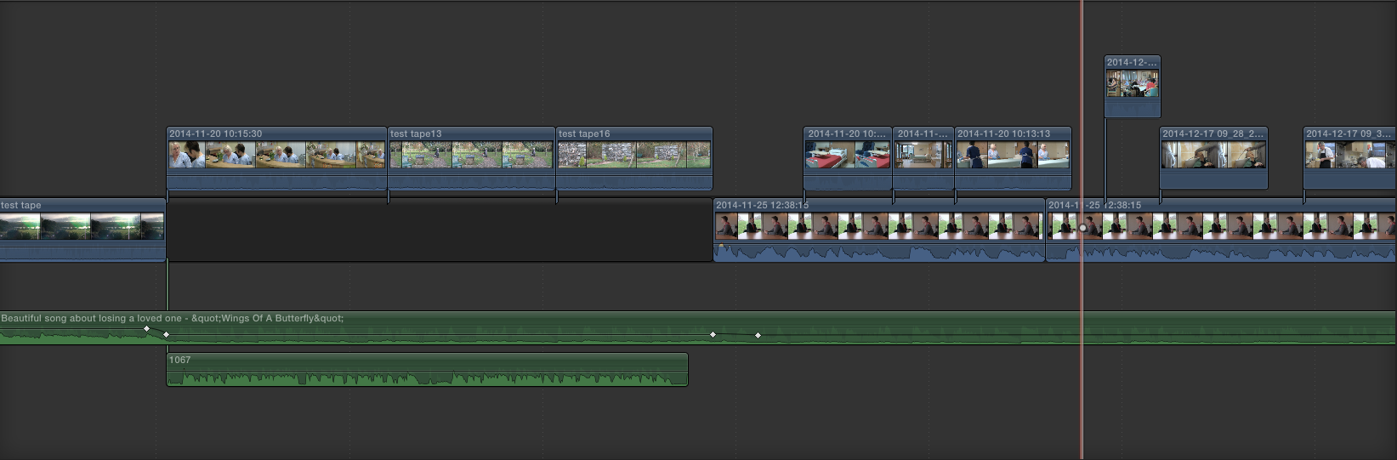
Storage and folder management; I used my hard drive to story the footage, and also had a file on two different computers as a back up so I wouldn’t lose it.

Online and offline editing; This is when you import your files onto your editing software, and then end up moving your files from where they’re stored on your storage device, which makes them ‘offline’. This means that the editing software cannot find where your files are storage.

Formats; Format is what quality of video you are using, eg 1080p HD etc.

Resolution; Quality of the image or footage you are importing, I used 1920x1080 for my social action. This is a high resolution (HD).

LO3. BE ABLE TO EDIT MOVING IMAGE MATERIAL

LO3.1 Editing technology:software applications; hardware, eg non-linear, linear;high definition;
standard definition; tapes; hard disc; data transfer rates;exporting productions;file types, eg mov, avi, flv; compression

Task 6. Describe what editing techniques you used to produce the work and provide a list of all editing equipment employed in production process.

Software
I used Final Cut pro to edit my video. I created a library and an event and imported all my footage to it, and then used the application to edit my movie. I created a time line and used basic techniques such as drag and drop, changing audio levels, increased the speed, fading music in and out. I also used text and transitions to make the credits.

Hardware
I used a mac to edit my social action project. In my opinion these are the best computers on the market for editing because of their speed, high resolution, and the software you can get on them which is easy to use.

Editing - non-linear and linear;Linear editing is an old form of editing, which took a lot of time and it came with a lot of pressure. The editor would take the strip of film, and use a razor blade and a diagonal splicing block to cut out the pieces of footage that wasn’t needed., Non-linear is the most popular form of editing now because of how quick it is. Digital editing on applications like Finalcut pro is an example of non-linear editing. It is much faster and more efficient and you are less likely to make expensive mistakes

High Definition(HD); Resolution is about the quality of the image and sound, the higher the resolution, the higher the quality. Resolution is to do with the number of pixels on display (width by height, so that 1024 × 768" means the width is 1024 pixels and the height is 768 pixels). HD can have different heights e.g. 1080p.The higher the HD the more detail the image holds, the more memory it takes up and the longer it will take to download.

Standard definition; Standard definition has a smaller resolution than HD. It downloads faster and takes less storage, but the image isn’t as sharp and detailed.

Tapes; We put our footage on tapes and transferred them onto the computer. We also had Digital tapes for our audio and video clips.

Hard disc; A hard drive disc is the most popular thing to store documents on. It is where I stored all my clips, pre production, and audio for my movie. It is a device that can be used to store digital information and can be plugged into different computers to access the material.

Data transfer rates; This is the speed that files are transmitted, measured in Megabits or Megabytes.

Exporting productions; This is exporting your movie when it is finished to upload to youtube etc. I exported my movie on final cut pro when it was finished. I used Quicktime to export my movie

File types; There are lots of different file types, eg mov, avi, flv, MOV is movie and plays on quicktime, AVI is audio video interleaved, and FLV is flash video.

LO3.2 Editing process: use appropriate techniques, eg seamless, continuity, motivated, montage, jump-cutting, parallel editing; use appropriate transitions, eg cut, dissolve, fade, wipe; use appropriate conventions, eg cutaways, cutting on action, creating juxtapositions, intercutting; pace effectively; convey information effectively; use sound to create impact; synchronise sound and vision; mix soundtracks; overlap sound; offline edit; online edit

Task 7. Describe editing techniques used and provide screen shots of editing techniques employed

I wanted to make the film look as best as it could to engage the audience. I wanted to use the most appropriate techniques for the subject matter. This meant the pacing had to be even but also interesting. I wanted the editing to be smooth and appropriate for the subject material and the audience. It wasn’t a drama or an action. It was a documentary to let a local community know about a project so I wanted to use the editing to show the material.

I wanted the editing to be seamless and I used this process a lot in my video. Seamless editing is where you put two different pieces of film together, and they still run smoothly into each other without any obvious difference. Most of my footage was cutaways to what the interviewee was talking about, I think in my documentary the part where we’re talking about the day hospice and the shots run seamlessly.
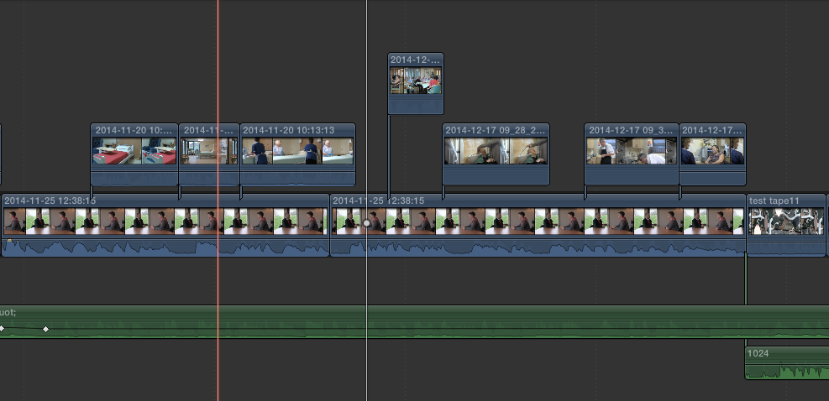
I used a lot of cutaways in my social action movie to keep the audience interested, because a moving shot of someone doing something related to what the interviewee is talking about, is more interesting than a still shot of the person talking.
I used an audio jump cut when Donall was talking and I used a cutaway so that it would be smooth and no-one would notice.

I used a fade transition when Michelle Kosky is introduced because I was talking and I didn’t want it to stop sharply but I wanted it to be smoother and fade in. I also used fade transitions in the credits. .
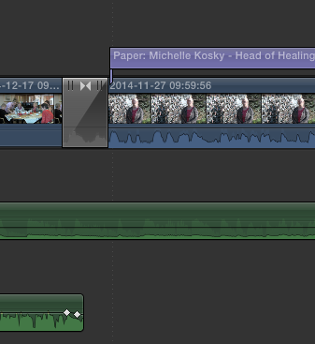
I did a montage when I was showing the day hospice and the different activities patients could do.
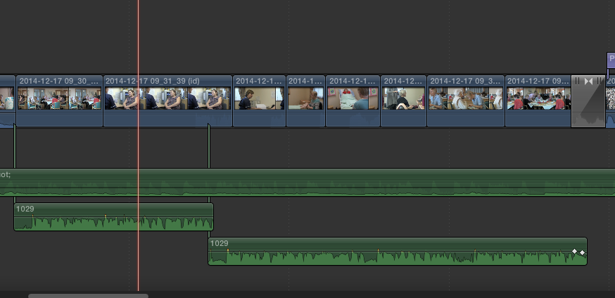

I used motivation editing as I wanted to shape the documentary by using the introduction and the different interviews to take the audience on a journey introducing a broad view of the hospice, its work, the importance of volunteering and how to volunteer, the effect of the work on its clients, the importance of fundraising events and I finished with one of these events.

I wanted to use the documentary to convey information effectively. We did this by planning out the interview questions, doing the interviews and then gathering information from the interviews to use as the voiceovers.

We used music to create impact. The music fades in and out throughout the film which adds to the continuity and creates a gentle and heartwarming feeling to reflect the work of the hospice.

I synchronised sound and vision to get the sound and video to merge well together. I used this not only with the musioc but also with voiceovers and with interviews. I wanted to keep the eye and the viewer interested rather than just listen to talking heads. It took me a while to fade the music in and out of the hospice but I finally got it done after a while. I had to make sure the images matched the sound track. It would have been to have extra shots but I worked with what I had and I learned the importance of research and planning shots. I don’t think the shots look too out of place.

I overlapped sound in my social action project so it sounds smoother. I overlapped the music with everything and also overlapped the voiceovers and interviews.

In professional editing situations, offline editing is the initial edit - sort of like a draft but a bit more than that. The goal of the offline edit is to create an edit decision list (EDL) which is basically a list of which shots go where. Once that's done you go to the online edit and just put the shots together as per the EDL. This is from the days when editing was done on tapes. I didn’t make out a list but had an idea in my head and just edited it as I went along and saw what it looked like.

LO3.3 Post-production tools: on screen text; image editing; audio editing Assessment and grading criteria.

Task 8. What credit and title techniques, audio techniques and music clips did you use.

I used various post-production tools. These include;

- On screen text; This is where screen comes up over a video in a movie, I did this to describe who Michelle was and I did it for my credits as well.

- Image editing; I had to change what the image looked like. eg I made one of my interviews with Donal brighter as the window was behind him and it was very dark.

- Audio editing; Audio editing is similar to image or video editing. It’s where you alter the sound of the audio to suit your needs for your radio piece or your video, or whatever you may need the audio for. I had to do this a lot while editing, as different people talked at different volumes. I also had to fade in and out of the music, it took me about a hour to sort out the audio because I had to make a lot of clips louder, and a lot of clips quieter.

- Music Clips. I used "Wings of a Butterfly (Backing Track)" by Jimmy Scott. I found it on-line and although I think it fits well with the documentary, there was an issue as it mentions souls and heaven and the hospice do not like to use these terms. The music needs to be changed to make it fit with the hospice but as I am on a deadline I will change it for Donall when I have the time.

- I used the shot of the Hospice van as an opening title which worked well as an opening title as the documentary is aimed at the local community and they would be familiar with the van out and about so it is something the audience would recognise.

- The credits were a tool on the Final Cut Pro. They were under the category sports but I though they fitted well.

ASSESSMENT AND GRADING CRITERIA
In order to pass this unit, the evidence that the learner presents for assessment needs to demonstrate that they can meet all the learning outcomes for the unit.
The assessment criteria for a pass grade describe the level of achievement required to pass this unit.

To achieve a pass grade the evidence must show that the learner is able to:

P1 Describe the development and principles of editing with some appropriate use of subject terminology
P2 Apply editing preparation techniques with some assistance
P3 Apply editing techniques working within appropriate conventions and with some assistance.
[CT]

To achieve a merit grade the evidence must show that, in addition to the pass criteria, the learner is able to:

M1 Explain the development and principles of editing with reference to detailed illustrative examples and with generally correct use of subject terminology
M2 Apply editing preparation techniques competently with only occasional assistance
M3 Apply editing techniques to a good technical standard showing some imagination and with only occasional assistance.

To achieve a distinction grade the evidence must show that, in addition to the pass and merit criteria, the learner is able to:

D1 Critically assess the development and principles of editing with supporting arguments and elucidated examples, and consistently using subject terminology correctly
D2 Apply editing preparation techniques to a technical quality that reflects near- professional standards, working independently to professional expectations
D3 Apply editing techniques to a technical quality that reflects near-professional standards, showing creativity and flair and working independently.

