About Me – Pre production.
By Michael Gomersall
Statement of Intention
- For my ‘About me’ project. I have undertaken all the Pre-Production Assignment requirements. The evidence is presented here. I document the process of completing all tasks including photo booth exercises, paired interviews and the making of a short movie. I will produce a film, around 2 minutes ’About Me’. I intend to have different cut scenes, montages and images relating to me and about me. I have already made a movie that has a bit to do with my life, and I intend to take a few clips out of this film to help me do my work. My work will be reviewed by my peers and an invited audience of guests on 9th October 2014.
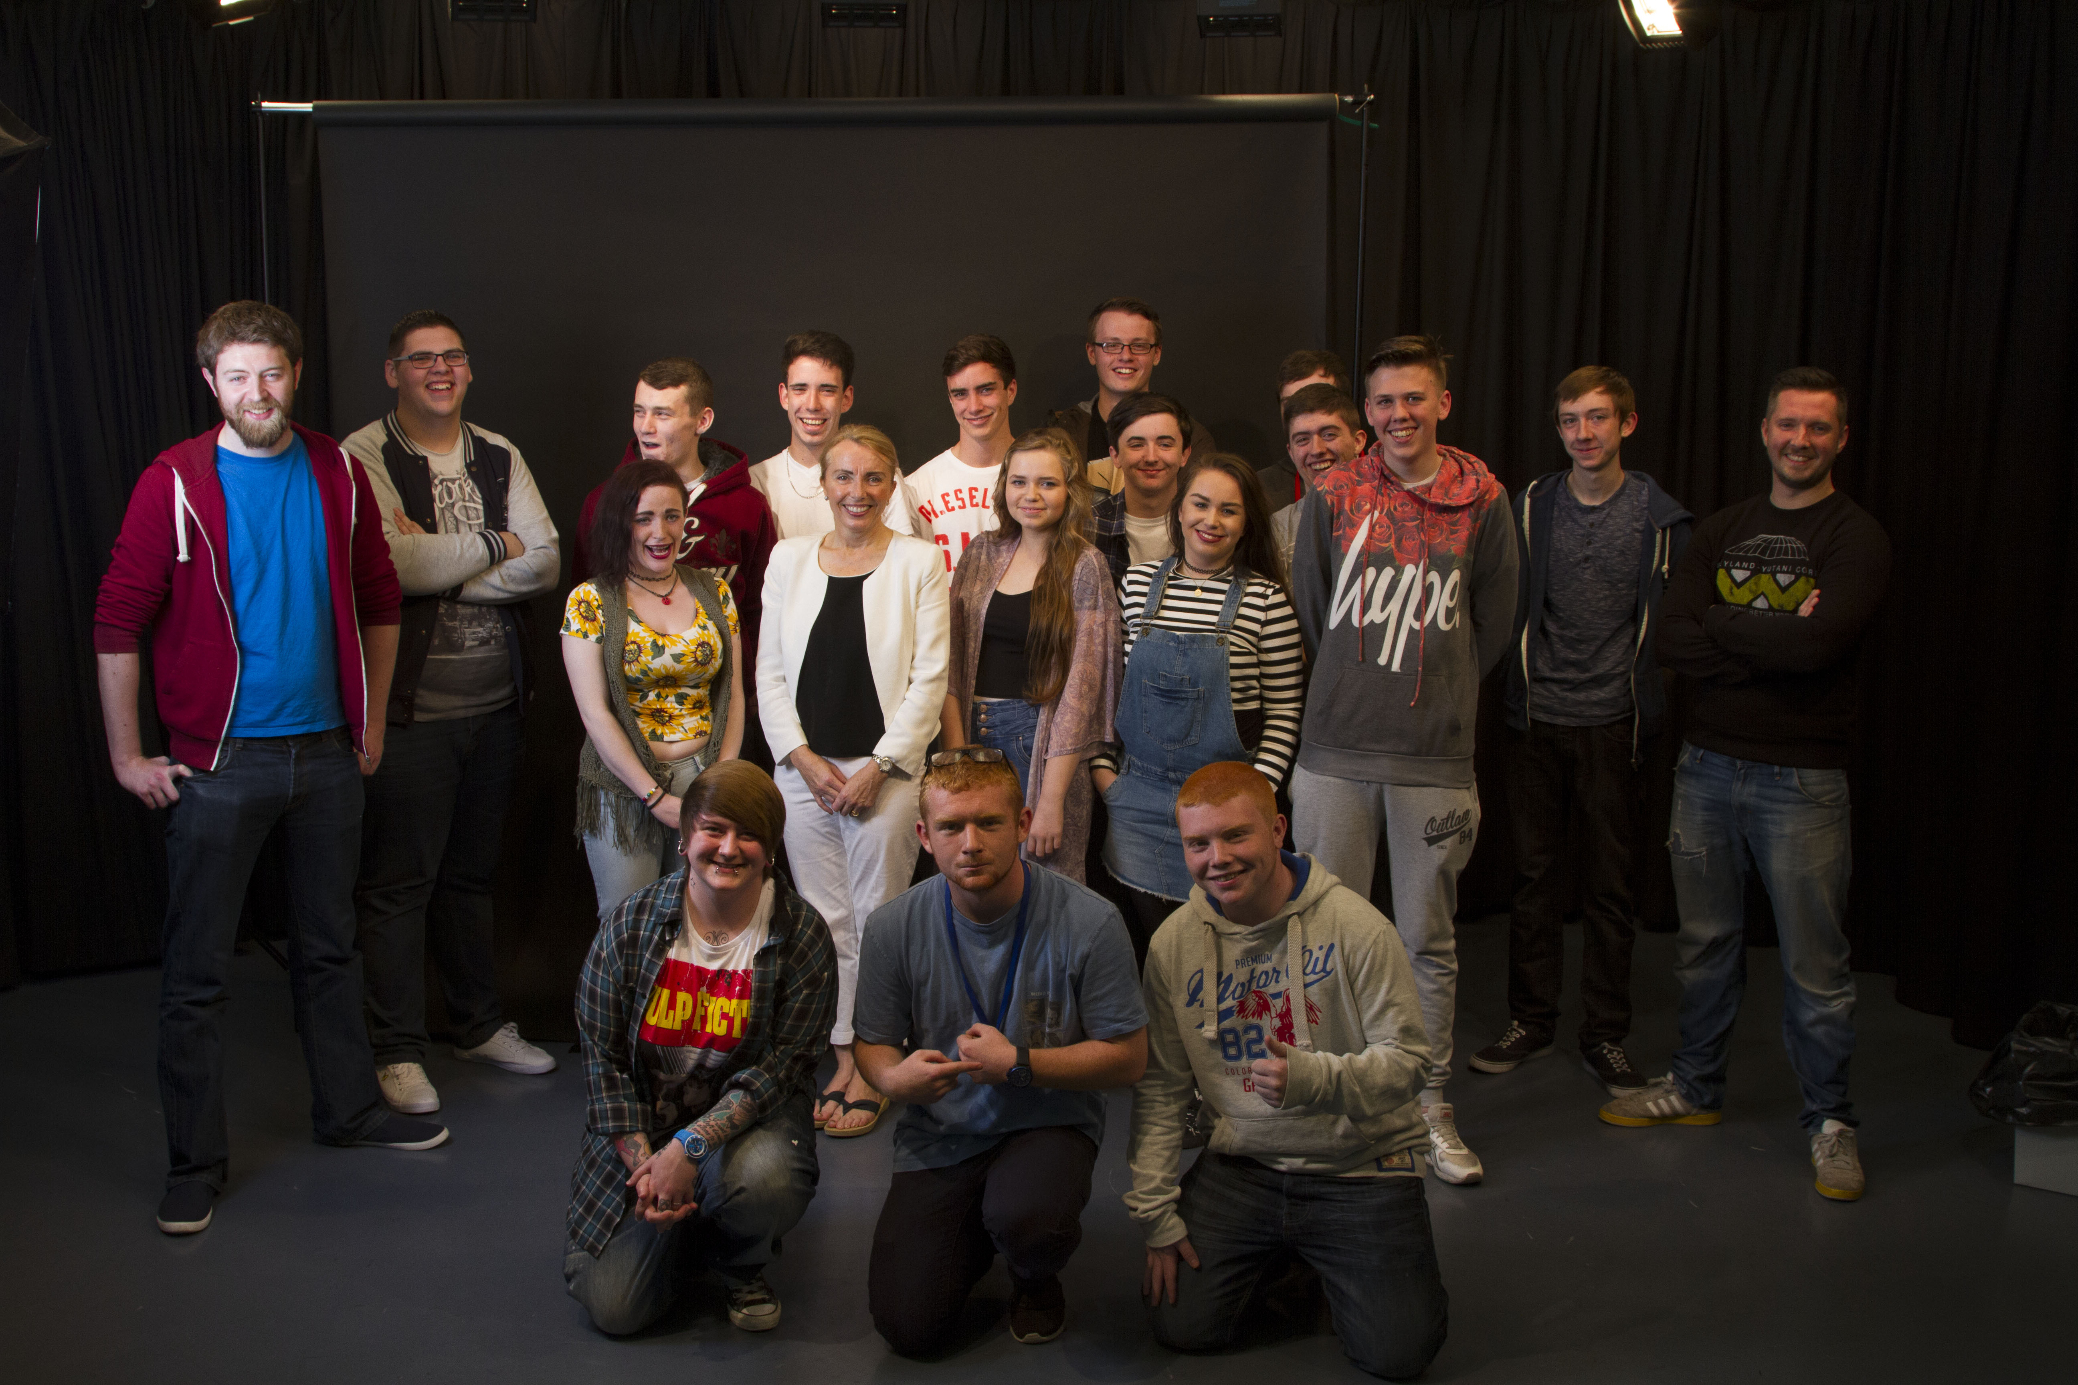
Ideas..
Interview myself and add in pictures and videos of me doing things.

Laugh and have fun.
Try to make it entertaining and happy and something people will enjoy to watch.

Add in voice overs and give someone questions to ask me and add them in.
Talk about kickboxing, my job, my friends, my family, my course, media and short film making.
Ask questions about the media course, but also personal questions about their hobbies and pass times.

Add music and montage of me doing things.

Open questions so the interviewer isn’t talking as much.

Pre production list, what I intend to have

- Budget; For my movie, I do not want to spend that much money, if any at all, I hope to only have to pay for travel to the different locations that I am going to film.

- Time; I am hoping to start my film on Friday and have it finished by the next week. It will probably take me 10-20 minutes to film me answering questions as I will have to film each one separately and I will have to keep going until I find my perfect shot, I will try to get that done on Friday, then some time throughout the week try and film in the different locations (if I haven’t got the film footage already on my phone or on youtube, e.g I already have videos of me fighting in kickboxing), so that will give me all of next week to edit.

- Crew; My crew will probably be small, as I will be doing most of the work myself(like the editing and acting) but I will ask one of my classmates to help me film my interview, or I could even try asking greg from the year 2 group.

- Facilities: I will have access to the north-west regional college and their equipment as I am attending the course there. I will have access to the professional cameras and the apple macs for editing software.

- Locations; Most of the filming will be the interview which I will try to do in class time. All the cutaways etc. I will probably have them as I have a lot of clips on my phone/computer and I will just download them onto the macs in class.

- Clearances; I don’t need any permission because I shot my film on the premises of the college that I am attending so I didn’t need any permission slips.

- Copyrights; I do not intend to break copyrights as most of the footage I will be using will be my own or I will have permission to use it.

- Health and safety; My footage has either already been filmed within the past year (for the montage) or will be in a small room where I am simply getting people to ask me questions, but I will still make sure the camera is on right so it wont fall and hurt anyone and make sure the cables are safe so no one trips over them.

- Applying production techniques to my movie; I am going to edit my movie and add in small montages or clips of me doing stuff while im talking or even at the same time at the side so you can see me talking and the picture/video at the same time.

- Gathering content and recording material; Most of the footage is already filmed and on my computer ready to be used. As for the interview, I will just record that in class time.

- Editing; I am going to edit on the mac, hopefully using iMovie as it is what I am used to and I really enjoy using this software, but I don’t really like any other software.

Questions to ask yourself.
Q.1;Tell us a bit about yourself.
Q.2;Why are you doing the Media production course at north west regional college.
Q.3; How are you finding the course and what do you think of the people?
Q.4; What do you hope to achieve after this course.
Q.5; Have you always been interested in media.
Q.6; Do you have any other hobbies or interests?
Q.7; Have you ever been in a proper fight in kickboxing?
Q.8; So now for my last question, to sum it off with something funny, whats your most embarrassing story, or the funniest thing you’ve ever done.

Answers
A.1; Well my names Michael, I’m 16 and I am in North west regional college doing a media course at the moment. I work in the multiplex in the bar but am looking to move to the cinema department.
A.2;Awwh I’m doing this course because I love media, always have, its so interesting and id love to have a job in advertising or movie making whenever I’m older, I love working on my own wee projects and love making my own wee stories. I’ve made movies before but they’ve only been a few minutes long.
A.3; I love the course, I find the editing and everything really enjoyable and I love planning and making up ideas in my head, the people are also really sound and helpful, I always take my lunches and breaks with them, they’re just genuinely nice people.
A.4; I hope to get high grades, I know that’s a lot to say but I think I really will put the work in, hopefully. Hopefully ill get to uni, and do the same course. Then afterwards go get a job high up, I know its planning far ahead but its just what I hope to do.
A.5; Yeah, defiantly, I even have small scripts, songs, movie ideas, advert ideas and more that I’ve done since the age of about 4.
I remember 1 add that I planned out when I was about 9, it was for walkers crisps and I still remember it to this day and have the sheet written out. It was a man who was about to go skydiving and they’re asking him questions like ‘we’ll give you a parachute that has a 50% chance of not working, and If you jump we’ll give you 1million pound’ the boy is hesitating and not saying yes, then they ask him ‘will you do it for a bag of walkers crisps’ and he says YES really enthusiastically and sharp, the final scene is a extreme long shot of him jumping off a cliff shouting ahhhh then you just hear him munching away at the crisps.
Q.6; Yeah I have loads of things to do in my spair time. I love going out with my friends and I have a wee shed out the back with sofas, speakers and everything, so we sit out there a lot. I love my friends I’ve always been a very sociable person, I don’t think I’ve sat in a day this year! –cut-
I also kick box, I train in top ring in Derry. I love training and have been there on/off for about 2 years, but I’ve had a lot of time off like during the summer when I was working in the bar. But I am getting back to it now that I’m not working as much as I was.
Q.7; Yeah, I’ve been in loads of spars and mat fights, but I’ve only had one ring show in front of a audience that I’m the main focus and it is in a proper ring, and not just a mat.
Q.8; Amm.. there’s a lot of funny things that have happened to me.. I think one of the funniest things ive done is whenever I sang Susan Boyle- I dreamed a dream dressed as a banana in front of my whole school.-cut-
It felt amazing, but nerve wrecking going up, but afterwards whenever everyone was laughing their heads off and cheering for me it felt absolutely amazing!

Pictures that I am going to use.
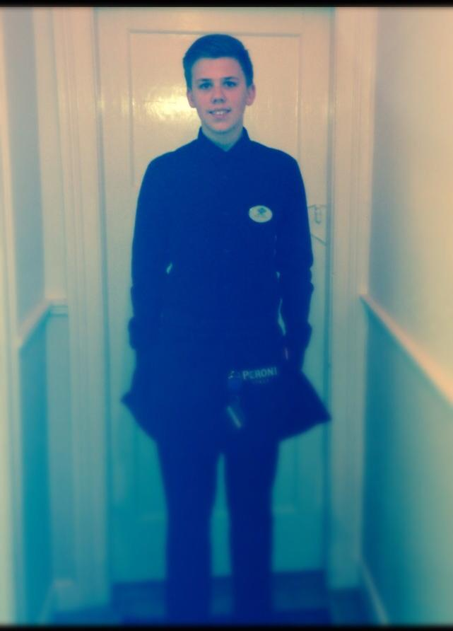

When I talk about work –

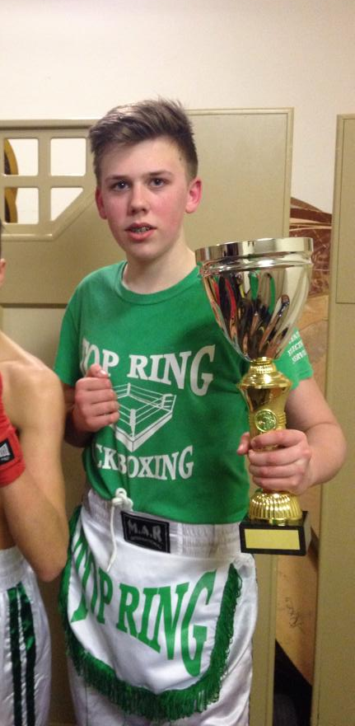

When I talk about kickboxing-

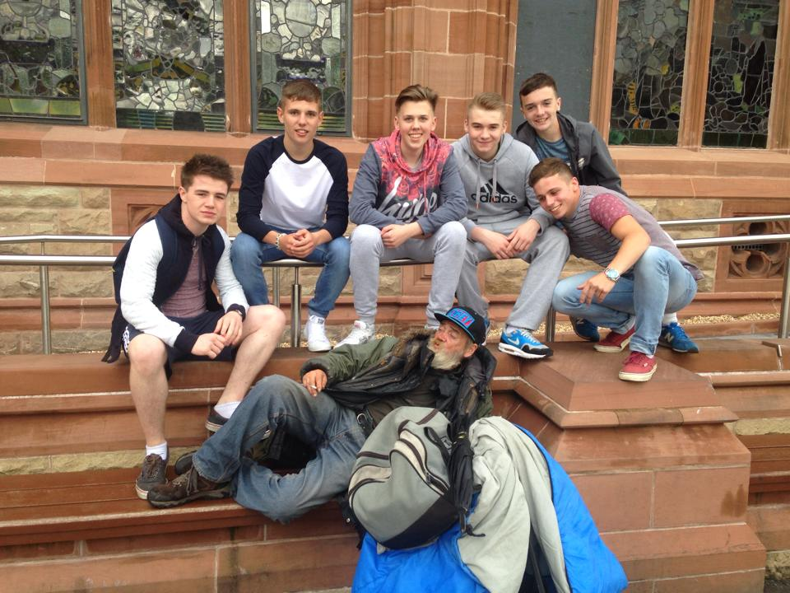

When I talk about friends-

For kickboxing I am also going to use videos of me fighting
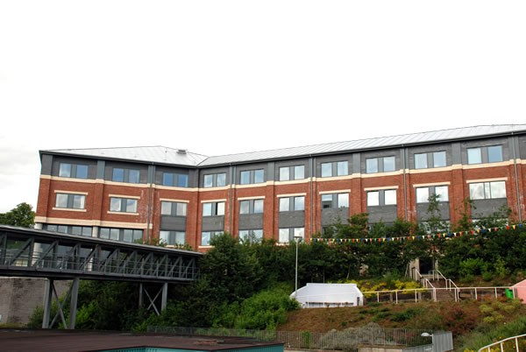

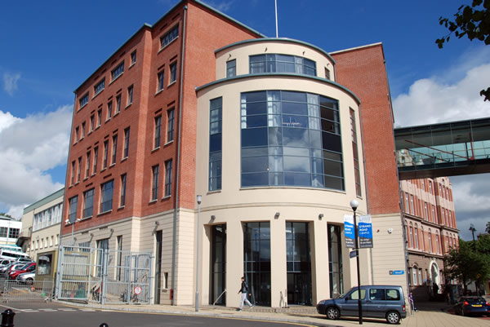
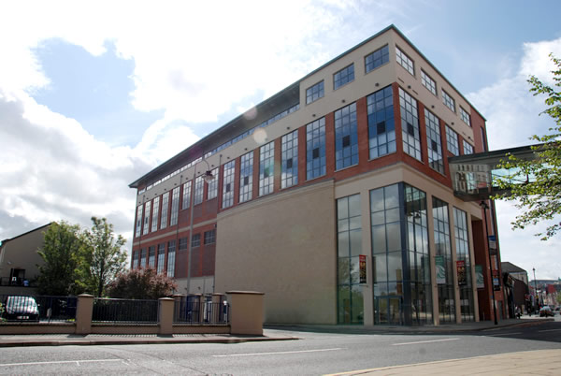
When I talk about about Northwest regional college-

When it says ‘ive made projects before ‘ cut away to some of the projects.
When I say the class is full of really enjoyable people -

When I talk about walkers crisps-

When I talk about me in a banana singing susan boyle go to the video footage of me singing it.

I hope to play a song in the background like ‘One day’ by Bakermat.

Conclusion
From doing this project I have learnt more about media and more about what I will be having to do in this course. I have learnt how to use the editing software ‘adobe premiere’ and how to add in pictures

