Foyle Hospice Volunteers
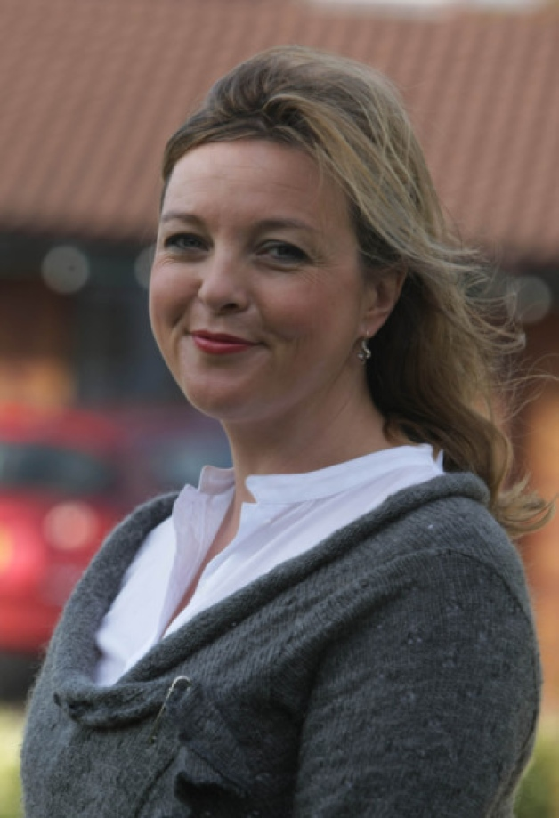

‘Stop thinking about it, pick up the phone’ – Sharon Williams

Most people in the North West have heard of the Foyle Hospice. The Hospice gives quality care to people who have cancer and other life-limiting illnesses. They only receive 20% of their funding from the government so rely on support from the local community and volunteers to raise money and provide services that they couldn’t otherwise afford.
I met with Sharon Williams who is the volunteer co-ordinator with the Foyle Hospice to find out what volunteers do.
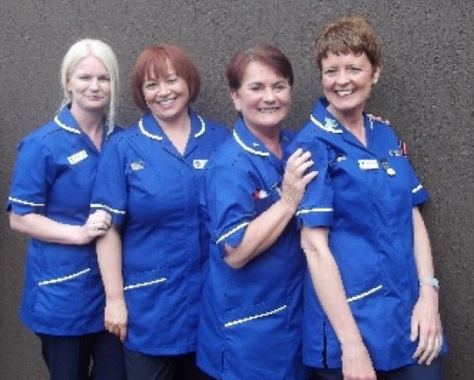
‘The work of the volunteers is critical to the hospice,’ Sharon tells me. ‘From day one, the community got involved in fundraising and through the last 30 years they have shown us support to help us provide our services free of charge to patients and families.’ So how exactly do the volunteers help raise the couple of million extra a year that the hospice needs?
‘Well we have over 500 people volunteering their time and their skills to the hospice. There are 5 charity shops which are open six days a week so the volunteers help run them. We have a weekly draw with 200 volunteers selling tickets –this draw creates huge revenue for us -and we put on lots of events and activities which volunteers promote and participate in.’
The hospice runs a day service where patients who are being cared for at home can come in to receive specialist care as well as having an opportunity to enjoy treatments such as art, music, complementary therapies or to get their hair done or a beauty treatment. Sharon explains how valuable volunteers are to this part of the work of the hospice. ‘Volunteers provide services that the hospice simply couldn’t afford without them –this provides a different dimension to the quality of care that patients and families receive whilst they are here,’ she smiles. Volunteers also serve tea, work in the kitchens and the beautiful grounds have been managed by volunteer gardeners for the past twenty years.
‘So what would you say to some-one who is thinking of volunteering?’ I ask Sharon. ‘Stop thinking about it and pick up the phone and do it’ Sharon replies. ‘It may feel a little bit intimidating if you have never volunteered before but after your first day helping out, you will never turn back. We would welcome your support. Some of our volunteers have been here for twenty plus years.’
The process is simple. You can call Sharon to discuss areas where there are opportunities. There is a volunteer enrolment form, which is available on-line.
‘We try to match people’s skills and experiences with opportunities that are available.’ Sharon says. ‘Volunteering is a two way process so it is important that volunteers get something back out of it. They are providing a service to us but they need to feel fulfilled or that they are contributing or maybe they want to learn new skills or put existing skills to good use. It’s a relationship –both parties get something out of it.’

Donall Henderson, the new CEO of the hospice thanks the volunteers and the local community.
‘Over the last thirty years the local community has been extremely generous. We only receive 20% of our funding from central government so we depend on very heavily on the generosity of the people in the North West. We couldn’t provide the service without the goodwill of the community and the volunteers who help us provide these services so we would extend a huge acknowledgement and a huge thanks to the volunteers and the general public for their continuous support.’
If you are interested in becoming a volunteer please contact Sharon on 02871351010 or email her at Sharon@foylehospice.com

Research from
http://foylehospice.com/volunteering
http://foylehospice.com/media/Volunteers/Volunteer_Information_Leaflet_1.pdf.
Interview with Sharon
Interview with Donall

