Show Reel
Hey, my name is Michael Gomersall, for the past year I have been studying creative media in the North West Regional Collage. We’ve been doing loads, from making a documentary, a music video and lots of written work and researching.
While that’s going on have some clips of the documentary, the music video and Michael sitting down and doing work
I say a lot of work, but a lot of the classes are just me and my friends talking and watching videos of Peppa Pig
Clip of Peppa Pig
When we started off, our class all made a biographical sketch, so we could find out a bit about each other and get to know each other.
The intro for my biographical sketch
We learnt how to edit on a couple of different softwares, and we learnt that if you keep changing your teachers picture to Louis Walsh, he will get annoyed.
Clip of Michael on the editing software, and of a computer minimising a browser and Louis Walsh being there, and a clip of Patsy shaking his head
We looked at interviews, and how interviewers can interview people in different ways, and how there’s different ways of interviewing.
Clip of maybe a more boring interview for a couple of seconds, then the clip of Joey Essex the quiz
We made a documentary about a charity, I chose the Foyle Hospice, and me and my group made the social action project.
Clip on Michael talking in the Foyle Hospice Documentary
We researched how to research, and trust me, this really helped us out in the future, as we have to research a lot.
Clip of Michael at the computer
We also did a project on the differences of Sky and BBC, a private TV company vs a Public TV company

We learnt about the History of Sky and BBC, and a bit about Rupert Murdoch
Clip of the first ever BBC broadcast with ‘First ever BBC broadcast’ at the bottom
We watch a lot of movies in the course, and have to think about them and discuss them, some people take it more serious than others
Clip of Ryan going mad about a crime drama or something along those lines
We’ve looked at presenters, and also been given some tips on how to be a good presenter, at the moment we’re making a music video and making this show reel, and doing other tasks like editing our presentations.
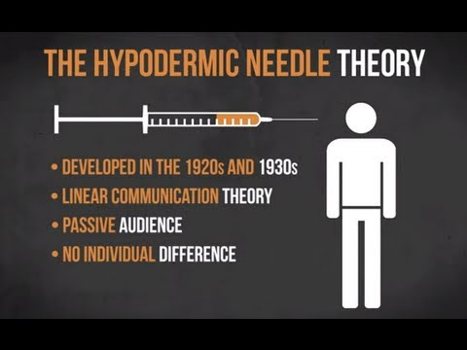
We’ve studied the film industry, and how people used to believe the hypodermic needle theory, and they thought that ideas and meanings were injected into the audience, and that the audience was passive and everyone was effected in the same way.
This picture and maybe a few video clips off youtube of the theory while michael is talking

We made a show that we had to present, I made one on my top 5 music videos
Clip of my presentation document
And on top of that we also made our own music video
Clip of my music video
But anyway, its been a good year, it’s been filled with work, talking to people and having the craic, watching funny videos on YouTube and tickling Jamie Keys
Clip of Michael Tickling Jamie
Anyway I hope you Enjoyed my Showreel, and hoped that you had as good as a year as I had in this course.

